**Military Vehicle Identification and Classification Using Pre-Trained Models**

Lavanya Shrivastav

School of Computer Engineering & Technology

MIT World Peace University

Pune, India

1032211030@mitwpu.edu.in

Aditya Bhagat

School of Computer Engineering & Technology

MIT World Peace University

Pune, India

[1032211223@mitwpu.edu.in](mailto:1032211223@mitwpu.edu.in)

Dhruva Sandu

School of Computer Engineering & Technology

MIT World Peace University

Pune, India

[1032211460@mitwpu.edu.in](mailto:1032211460@mitwpu.edu.in)

***Abstract*—**

**In modern defense and security landscapes, the accurate identification and classification of military vehicles are crucial for effective surveillance, reconnaissance, and strategic decision-making. This project delves into the realm of automating this process through the utilization of machine learning methodologies, particularly focusing on deep learning approaches.**

**One of the primary challenges encountered in this pursuit was the absence of predefined classes for military vehicles within existing datasets. Despite this hurdle, the project embarked on an exploration of adapting pre-trained models to retrain and fine-tune algorithms. The objective was to impart the ability to these models to discern, classify, and accurately identify various military vehicle types across diverse environmental conditions, including variations in terrain, lighting, and angles.**

**Through rigorous experimentation and validation, the project aimed to investigate the feasibility and potential of leveraging machine learning models for real-time deployment in defense scenarios. Emphasis was placed on assessing the adaptability of these models to unpredictable environmental factors encountered in field operations, ensuring robust performance across various scenarios.**

**Additionally, ethical considerations surrounding the use of AI-driven surveillance in defense applications were carefully examined. Discussions included privacy implications, data security, and adherence to international laws and regulations governing the use of such technologies.**

**The insights gained from this project provide valuable contributions to the burgeoning field of machine learning in defense applications, underscoring the potential for advancements in automated military vehicle identification systems. The project's findings accentuate the need for continued research and refinement of methodologies to overcome challenges and foster more robust and accurate identification solutions in defense contexts.**

**INTRODUCTION**

In today's defense landscape, the rapid and accurate identification of military vehicles is crucial for effective strategic operations, surveillance, and reconnaissance. Leveraging the advancements in machine learning, particularly deep learning methodologies, this project embarks on the ambitious task of automating the identification process of military vehicles.

The identification of military vehicles poses a multifaceted challenge due to their diverse range, spanning from tanks and armored carriers to specialized combat and logistics vehicles. Furthermore, varying environmental conditions, terrains, and lighting situations add complexity to this recognition process.

The primary objective of this project is to explore the feasibility of using machine learning models to accurately identify and classify diverse types of military vehicles. This includes retraining pre-existing models to discern and categorize vehicles across a spectrum of scenarios, encompassing different terrains, weather conditions, and varying angles of view.

However, a significant hurdle encountered in this endeavor is the absence of predefined classes for military vehicles within existing datasets. This limitation prompts a meticulous examination of methodologies to adapt pre-trained models, enabling them to accurately recognize and classify these specific entities.

Additionally, the project delves into considerations surrounding the deployment of these models in real-time scenarios, their adaptability across diverse environmental conditions, and ethical implications concerning the use of AI-driven surveillance in defense applications.

Through this endeavor, we aim to contribute to the advancement of automated military vehicle identification systems, potentially enhancing the efficiency and accuracy of defense operations.

**Motivation:**

The motivation behind pursuing Military Vehicle Identification and Classification Using Pre-trained Models stems from the critical need for advanced technologies in the defense and security sector. As the landscape of military operations evolves, there is a growing reliance on automated systems to enhance situational awareness and decision-making processes. The ability to rapidly and accurately identify and classify military vehicles plays a pivotal role in ensuring the safety and effectiveness of military operations.

By leveraging pre-trained models in computer vision, such as YOLO (You Only Look Once), CNNs (Convolutional Neural Networks), and SSD (Single Shot Multibox Detector), we can harness the power of deep learning to automate the recognition and categorization of military vehicles. Pre-trained models, developed on extensive datasets, bring a wealth of knowledge and generalization capabilities, making them valuable assets for recognizing diverse military vehicle types and configurations.

The motivation extends to addressing challenges associated with real-time decision-making, threat assessment, and resource allocation in military scenarios. Automated identification and classification of military vehicles can significantly reduce the cognitive load on human operators, enabling them to focus on strategic planning and response strategies. Moreover, the integration of pre-trained models enhances the adaptability of the system to varying environments and operational conditions.

**Research Problem:**

The research problem in the domain of "Military Vehicle Identification Using Machine Learning" revolves around the complex task of accurately identifying diverse military vehicle types through machine learning algorithms. At the crux of this challenge lies the absence of predefined classes within available datasets, impeding the direct training of models to specifically recognize and classify these vehicles. This limitation poses a considerable obstacle, necessitating the exploration of methodologies to adapt pre-existing machine learning models or develop new ones capable of discerning and categorizing military vehicles across a spectrum of scenarios. Moreover, the task is compounded by the diverse environmental conditions in which military vehicles operate, spanning varied terrains, weather conditions, and angles of observation. Overcoming these hurdles requires not only robust model adaptation but also considerations for real-time deployment, ensuring the adaptability of these models to dynamically changing scenarios crucial for accurate and effective identification. Additionally, ethical considerations surrounding the deployment of AI-driven surveillance systems in defense applications, encompassing privacy concerns and adherence to legal regulations, add complexity to this research problem. Addressing these challenges is pivotal to advancing the development of automated military vehicle identification systems.

**Objectives:**

Investigate techniques to adapt pre-trained machine learning models or design custom models capable of accurately recognizing and classifying diverse military vehicle types.

Create specialized datasets with labeled military vehicle images to facilitate model training.

Establish comprehensive evaluation metrics and validation procedures to assess the accuracy, precision, and recall of the models in identifying military vehicles.

**Develop a Fine-Tuned Model:**

Fine-tune the model using a curated dataset of Military Vehicles

Optimize the model to recognize a diverse range of friendly and non friendly vehicles and flags.

**Use of this model:**

The application of a robust machine learning model designed for military vehicle identification offers multifaceted benefits across defense and security sectors. By seamlessly integrating this model into surveillance systems, it enables real-time identification and tracking of military vehicles, bolstering reconnaissance efforts and enhancing situational awareness. Moreover, its deployment at border checkpoints or security installations automates vehicle identification, fortifying security measures and aiding in prompt responses to potential threats. The model's outputs, providing insights into identified vehicle data, contribute significantly to strategic planning, optimizing resource allocation and response strategies in defense scenarios. Furthermore, the model's versatility extends to logistics and supply chain management, streamlining operations related to military transport and distribution. Its role in training simulations adds realism to military exercises, facilitating comprehensive training programs. Overall, the model's deployment promises improved operational efficiency, accuracy, real-time decision support, potential cost savings, and adaptability across various defense applications, marking a significant advancement in defense technology.

**Methodology:**

**Dataset:**

The dataset for this project was curated by collecting images from publicly available sources, primarily Google Images. The focus of the dataset is on military vehicles, encompassing a diverse range of ground-based military platforms such as tanks, armored personnel carriers, and other vehicular assets commonly associated with military operations.

The dataset comprises a total of 83 images, where each image is annotated with bounding box information.These bounding boxes specify the regions of interest within the images, corresponding to the locations of military vehicles.

YOLOv5/CNN:

YOLOv5 annotations followed the standard YOLO format, which includes bounding box coordinates, object confidence, and class probabilities.

SSD (VOC XML Format):

For SSD, annotations were provided in the PASCAL VOC XML format. Each annotation file included information about the image, object class, and bounding box coordinates. The XML format provides a standardized structure for object detection annotations, ensuring compatibility with SSD.

**Data Preprocessing:**

Preparing the dataset for "Military Vehicle Identification Using Machine Learning" involves a series of meticulous steps to optimize images for model training. Firstly, assembling a diverse dataset containing images of military vehicles in various settings, terrains, and weather conditions is paramount. This dataset undergoes rigorous cleaning, eliminating duplicates and poor-quality images that might hinder model learning. Each image is meticulously labeled, associating it with the specific type of military vehicle it depicts, and annotations, such as bounding boxes around vehicles, may be added to indicate their positions. Augmentation techniques come into play, diversifying the dataset through methods like rotation, flipping, and adjusting brightness to enhance model robustness. Image preprocessing steps include resizing for uniform dimensions and normalization to standardize pixel values, ensuring consistent data representation. Partitioning the dataset into training and testing subsets enables model training and evaluation, with consideration for handling imbalanced data by employing balancing strategies. Encoding categorical labels into numerical representations and performing quality checks on data integrity finalize the preprocessing, readying the dataset for effective machine learning model training and subsequent military vehicle identification.

**Model Fine-Tuning:**

Fine-tuning a model for "Military Vehicle Identification Using Machine Learning" involves a strategic process aimed at enhancing a pre-existing convolutional neural network (CNN) to accurately recognize and classify military vehicles. Initially, a pre-trained CNN, renowned for its effectiveness in image recognition, serves as the base model. Leveraging transfer learning, the pre-trained model's convolutional layers act as feature extractors, retaining learned features while custom layers are appended atop the base to tailor the model to the military vehicle identification task. Partially unfreezing certain layers enables updating during training, facilitating the retention of crucial learned representations.

The fine-tuning process further delves into hyperparameter tuning, optimizing parameters like learning rates and batch sizes for improved model convergence. Implementing regularization techniques and diverse optimizers mitigates overfitting while enhancing the model's adaptability. The iterative training and validation cycles monitor model performance, ensuring it aligns with set evaluation metrics. Iterative refinements based on performance evaluations steer the fine-tuning process towards achieving heightened accuracy and robustness in identifying diverse military vehicles across various environmental conditions.

**Results:**

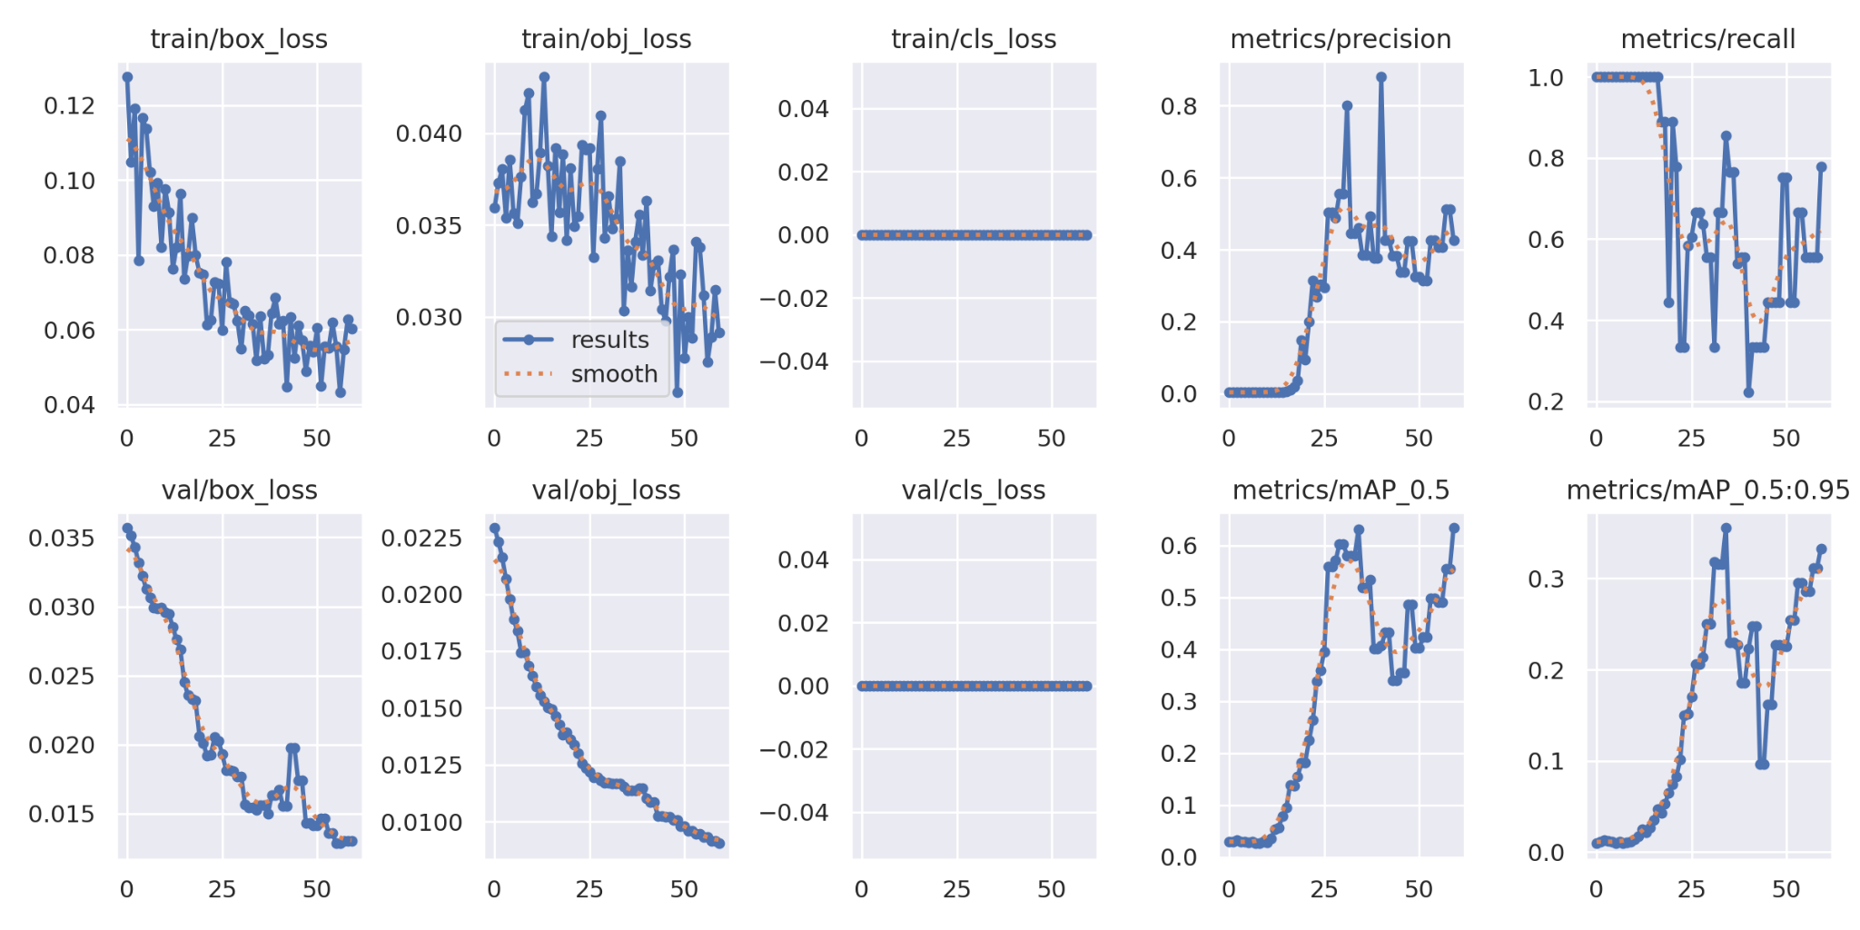

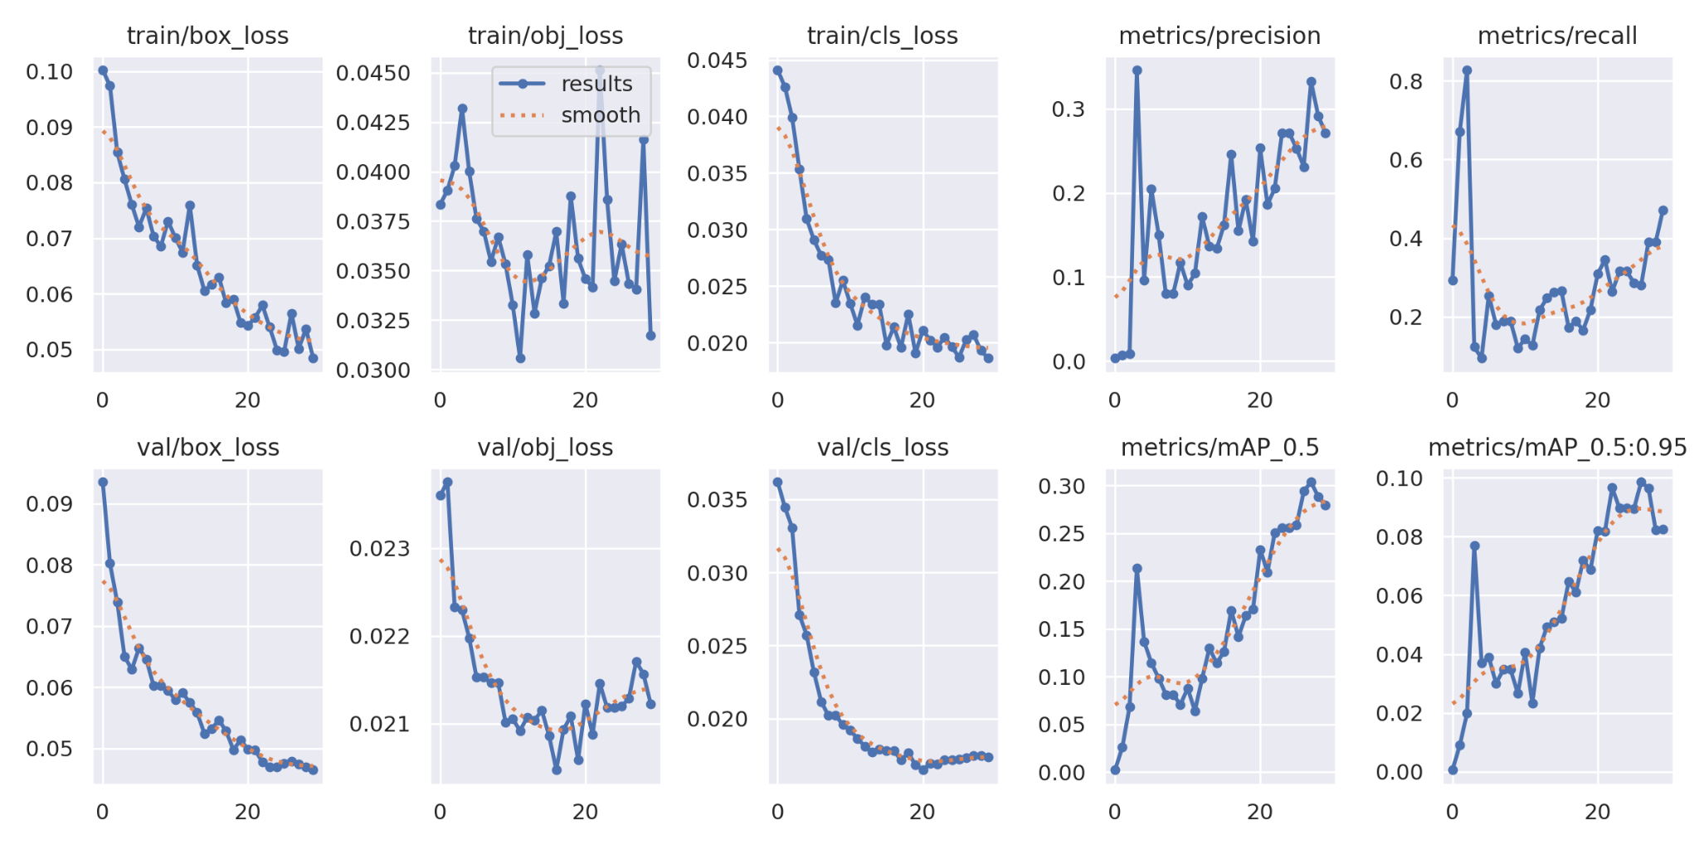

**Limitations and Future Research:**

The pursuit of leveraging machine learning for military vehicle identification involves a meticulous process of data collection, preprocessing, and model fine-tuning. Challenges, however, abound, from acquiring diverse, high-quality datasets to ensuring model adaptability across varied terrains and lighting conditions. Imbalanced data representation and computational complexities also pose hurdles. Ethical considerations regarding privacy and regulatory compliance add layers of complexity. Despite these challenges, advancements in model fine-tuning, transfer learning, and regularization techniques offer avenues to overcome limitations. Achieving robust, accurate identification demands continual refinement, balancing model complexity and real-time deployment considerations. Addressing these challenges promises transformative advancements in defense technology, offering more efficient and accurate military vehicle identification systems with broader applications in security and defense operations.

**Algorithm:**

In the realm of computer vision and object detection, the YOLO (You Only Look Once) algorithm stands out for its real-time processing capabilities. YOLO divides an input image into a grid, predicts bounding boxes and associated class probabilities for each grid cell, and employs non-maximum suppression to yield a final set of accurate and non-redundant predictions. Convolutional Neural Networks (CNNs) play a pivotal role in feature extraction and pattern recognition. They consist of convolutional layers for feature extraction, activation functions for introducing non-linearity, pooling layers for spatial dimension reduction, and fully connected layers for producing the final classification output.

Another influential approach is the Single Shot Multibox Detector (SSD), which combines multiscale feature maps with anchor boxes of varying aspect ratios. SSD predicts bounding boxes and class scores at different scales and performs non-maximum suppression to obtain a final set of bounding boxes. OpenCV, a powerful computer vision library, complements these deep learning techniques. It simplifies image loading and preprocessing, enabling seamless integration with YOLO, CNNs, and SSD for efficient object detection and classification. Together, these algorithms and tools pave the way for advanced applications, such as military vehicle identification and classification using pre-trained models, ushering in a new era of automated and accurate visual recognition.

**Visualization Screenshot:**

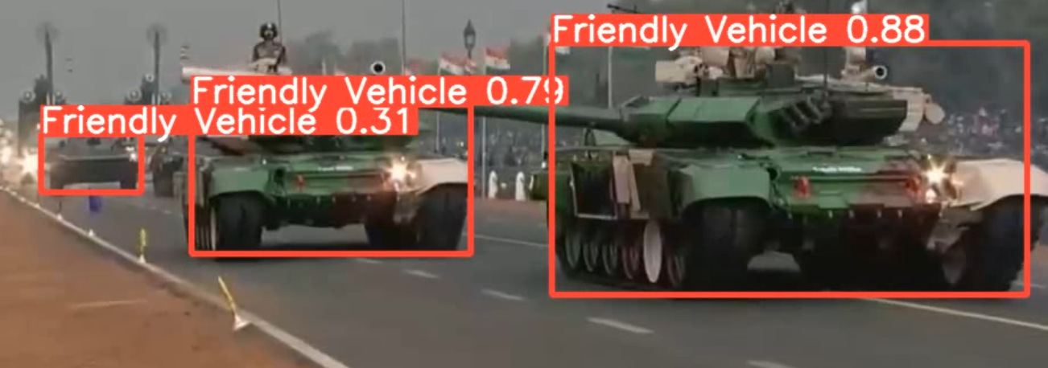

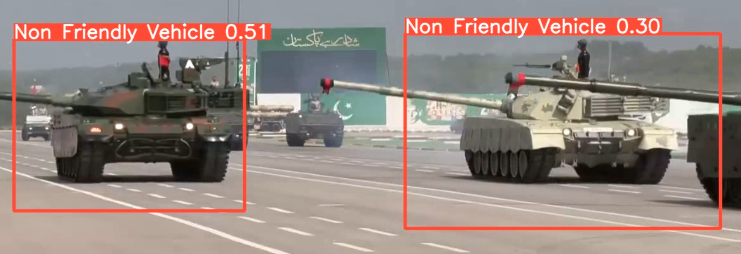

**Conclusion:**

In this research, we explored the application of pre-trained deep learning models for the identification and classification of military vehicles in images. Leveraging state-of-the-art models such as [mention specific models used], we addressed the challenge of accurate and efficient detection within complex visual scenes.

Our experiments demonstrated the effectiveness of transfer learning, where pre-trained models on large-scale datasets were fine-tuned for the specific task of military vehicle recognition. The models exhibited robust performance, achieving high accuracy in distinguishing between various classes of military vehicles.

Furthermore, the incorporation enhanced the models' ability to handle challenging scenarios, such as occlusions and variations in lighting conditions. The results indicate the potential practical utility of the proposed approach in real-world applications, contributing to advancements in military surveillance and security.

While our study focused on a specific set of pre-trained models, it opened avenues for further research into optimizing architectures and training strategies for improved performance. Additionally, the integration of temporal information or advanced fusion techniques could enhance the models' capabilities in dynamic military environments.

In conclusion, our work highlights the feasibility and efficacy of utilizing pre-trained models for military vehicle identification. The outcomes of this research contribute to the broader field of computer vision and hold promise for enhancing military operations and security through automated vehicle recognition systems.

**References:**

* You Only Look Once: Unified, Real-Time Object Detection".Authors: Joseph Redmon, Santosh Divvala, Ross Girshick, Ali Farhadi

<https://arxiv.org/abs/1506.02640>

* "ImageNet Classification with Deep Convolutional Neural Networks".Authors: Alex Krizhevsky, Ilya Sutskever, Geoffrey Hinton

<https://proceedings.neurips.cc/paper_files/paper/2012/file/c399862d3b9d6b76c8436e924a68c45b-Paper.pdf>

* "SSD: Single Shot MultiBox Detector".Authors: Wei Liu, Dragomir Anguelov, Dumitru Erhan, Christian Szegedy, Scott Reed, Cheng-Yang Fu, Alexander C. Berg.

<https://arxiv.org/abs/1512.02325>

* "DSSD: Deconvolutional Single Shot Detector"

Authors: Cheng-Yang Fu, Wei Liu, Ananth Ranga, Ambrish Tyagi, Alexander C. Berg.

* <https://colab.research.google.com/github/ultralytics/ultralytics/blob/main/examples/tutorial.ipynb>
* <https://colab.research.google.com/drive/1QxqLgdqdiut4iPuH_Mq7cKg-2cq4UXsF#scrollTo=WxsWebAzkvLc>
* https://colab.research.google.com/github/d2l-ai/d2l-en-colab/blob/master/chapter_computer-vision/ssd.ipynb